eBlessings International Daily Devotional Archives
Visit DOT, and WOW Empowerment Series,
plus Prophecy, Spiritual Keys & Lessons, IA, PP and more...

Each One! Bless One!
You Make a Difference!

* * * * *
Share |

The main aim of this home is to develop these children
in Christian faith, so that in their later days they may become strong soldiers for Christ so they can save many souls for Him.

“For I was an hungred, and ye gave me meat: I was thirsty, and ye gave me drink: I was a stranger, and ye took me in: Naked, and ye clothed me: I was sick, and ye visited me: I was in prison, and ye came unto me. Then shall the righteous answer him, saying, Lord, when saw we thee an hungred, and fed thee? or thirsty, and gave thee drink?”
MATTHEW 25:35-37 (KJ)

eBlessings Pakistan Children’s Home. Greetings Beloved Sisters and Brothers in Christ Jesus! We are running a Children's Home. At present 25 poor and needy children are being taken care of. We are giving spiritual education and general education to these children and also providing them food and clothes and entertainment and sports.

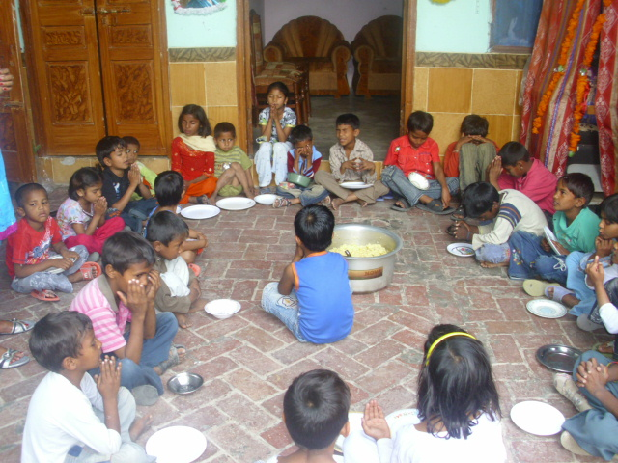
Ms. Robina, the supporting team and the spiritual leadership are providing spiritual education and guiding them to grow well in the Christian faith. The Main Aim of this Home is to develop these children in Christian faith, so that in their later days they may become strong soldiers of Christ to earn many souls for Him. We are unable to meet the educational needs of these children ourselves to purchase books, notes, uniforms and food for orphans and the hungriest and the poorest children.

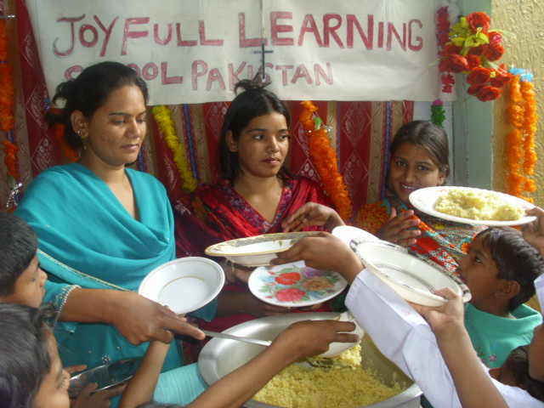
In Pakistan Christians are persecuted. There are extremely few opportunities for Christians for economic development; no freedom, no equal status with Muslims. Muslims according their faith they consider Christians to be unclean creations and do not like to touch the Christian or eat together with Christians in the same pot. They always work to defeat Christians in Pakistan in all levels of life; every day in every area of life. So we Christians are living under the threat and fear of our lives daily. We have no hope, but are just passing the days of their lives. We depend on Christ Jesus and we depend on our Brothers and Sisters in Christ.

By profession, Christians are only doing road-cleaning work, and are servants in the houses of Muslims and doing sanitation work, as Muslims never ever give opportunity to Christian to mix with them. So our new generations, our children, the new Pakistani Christians need education and faith, so they can face all challenges in Pakistan by being taught Christian faith. We really need your financial support and that support goes a long way.

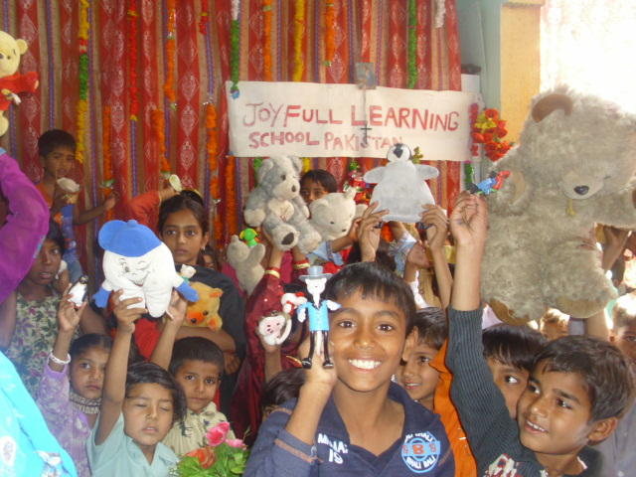
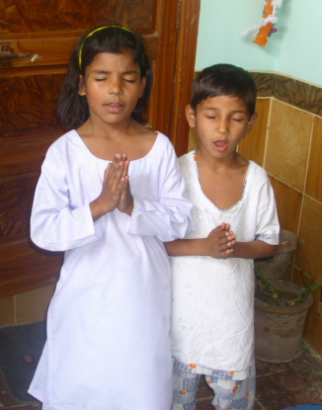
We appeal to you and if you are impressed by the love of Jesus, and have the Compassion of Christ, please do extend helping hands towards helping these needy children for school fees, books, notebooks and uniforms for 15 children. Kindly treat these deprived children as your own children and help them. The Home is run fully by faith and the Lord provides our needs through His children. If the Lord leads you to extend your helping hand to this Home to develop the future generation of evangelists, your gift will be used for providing a child with shelter, food, clothing, and education. Donate!! Thank you for your love...
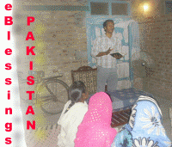
Christ love be in you!

Pastor Ameir Masih
and Team Pakistan
eBlessings Pakistan
The message from
a Christian Community in Pakistan
Email: mailtts@yahoo.com

