eBlessings International Daily Devotional Archives
enrich, inspire, encourage, bless, and empower spiritual warriors for end-time battles!
MARCH 2010 MARCH 2010 MARCH 2010
IDD 2004 | IDD 2005 | IDD 2006 | IDD 2007 | IDD 2008 | IDD 2009 | IDD 2010
Visit DOT, and WOW Empowerment Series, plus Prophecy, Spiritual Keys & Lessons, IA, PP and more...

Each One! Bless One!
You Make a Difference!

* * * * *

Monthly Reports, Part Two:
December January and February 2010 Reports
(CONTINUED)

Dear Precious Brother & Friend James,

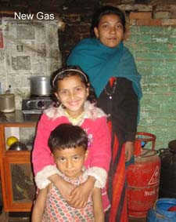
Gas Purchase: For some poor families, it is a desire and it takes a long planning to have gas and stove for cooking. Poor have their kitchen and bedroom together in small-congested room in a muddy house. This is the everyday life of poor in Nepal. For some people this is unimaginable. (Like you and me—Americas/Europe/Russia/Asia (jaa)) It smells like kerosene in the house and it becomes very hot to the eyes (burning the eyes) that you can't see.

Shova has been cooking in this style for so many years. When she was blessed with Gas and Stove she was very glad. She told us that 'I am so glad to have this stove, I have been praying for this, now my two children can do their school home work without any trouble.' (Imagine the discomfort of children doing their homework with burning eyes and fumes in their noses; now happy to have it! That speaks volumes!)

It is so glad to exchange our blessing (give a blessing) to them. (Blessings exchanging hands.) God's children should exchange their resources because there is where the blessing is. “Give and it shall be given unto you.”

Gospel Friendly Matches: We played many friendly matches and shared the gospel to the players and to those standing by. A sports is just an excuse to tell the Gospel to them. We give Gospel tracts to side walkers, watchers and to everybody who comes on our way.

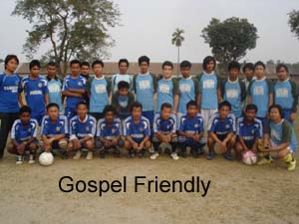
We need sports tracts to approach athlete. (Fellowship of Christian Athletes/Kurt Warner/Athletes in Action) We would like to reach the youth of this generation with the gospel of Jesus Christ through the mediums of sports.

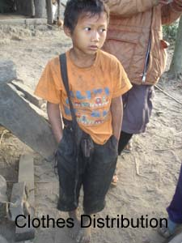
Clothes Distributed to Poor: It has been a privilege to serve poor children and a widow in January. James 1:27 tells us to care for the orphans and widows, 'What God the Father considers to be pure and genuine religion is this: to take care of the orphans and widows in their suffering'.

In January, we were able to distribute shoes, school bags, jackets, trousers, sweaters, caps, and other items to the poor children in Kathmandu and in Dungdunge, in east Nepal.

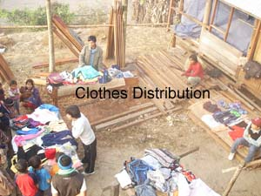

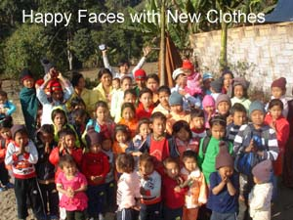

An Old Widow Visited: In my recent visit to the churches in village, I found a woman of 81 years of age, a widow, and a believer of 8 years. Her name is Manshari. She walks to the church with her staff (stick) every week to attend a weekly service and loves the Lord with all her heart. Her husband died 24 years ago and she didn't have a child.

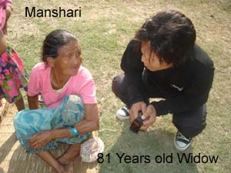
She is living with one of the believer's family. I think she is worthy of our consideration. When I heard about her I told Binod, one of our brothers in ministry, 'we are going to meet this widow tomorrow morning 5 AM.’ When I reached there I told her that, Bible tells us to care for the orphans and widow, so here am I.' She was so glad to see us, and we too. If there are someone who wants to share Christian love to this widow you are very much welcome. (Send money to her through Reuben at his website.)

Church Boys United is registered: We registered a football organization in East Nepal too, in Morang district. We are planning to reach many youths, children in schools and villages to share the Gospel. Lots of things to do. Is not it? (Is there not many, many things to do for Christ to bring in the Harvest?)

We would like to see the name of Jesus appear in newspapers, and Medias. So that name of Jesus is preached. When we registered organization, we have legal privilege to work and organize cultural programs through which we can tell others about Jesus Christ. They have requested us to visit their Church and organize meetings in the future.
(TO BE CONTINUED)

COME, SEND MONEY/TRACTS; THE HARVEST FIELDS ARE RIPE

Brother Reuben Rai and Family
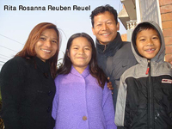
A little servant of a very Big God
From "a rented house" in Kathmandu
Phone: +977-98510-12105, +977-97510-02328
Mailing Address: GPO 8975 EPC 2030, Kathmandu
Skype: reubenrai
www.churchesnetwork.com

